ONE DAY EVENT

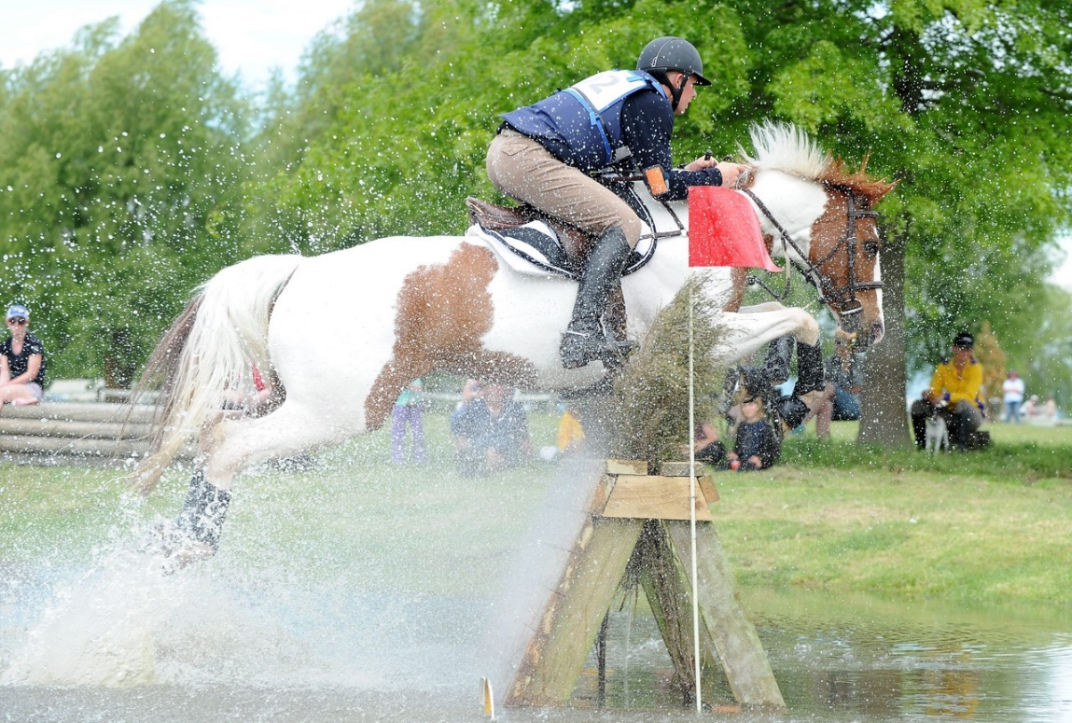

Hawke’s Bay Equestrian Park
Sat 5th - Sun 6th November 2016

Flaxmere Pony Club wish to thank our generous sponsors for their support
Thank you to Kampic for their continued support of our events.

If you would like to order photographs from this event: - go to www.kampic.com & select the Equestrian Images folder. In there will be a folder for the ODE. You can browse through photos and add to your cart (selecting the type and size you would like). Once you have all the photos you would like in the cart select CHECKOUT and follow the steps to input email address / delivery address etc
Please show your support to them whenever possible.
OFFICIALS

Event co-ordinator | Elizabeth McCrory
Event Secretary | Raewyn O’Connor
Officials Convener | Raewyn O’Connor & Elizabeth McCrory
Technical Delegate | Alan Tonge
Assistant Technical Delegate | Shane Tilson
Pony Club District Commissioner | Cathie Forde
Sponsorship Convener | Raewyn O’Connor
Gear Safety Inspection Convener | Leanne Harkness
Event Treasurer | Catherine Howell
Programme | Leanne Harkness
Hospitality | Emma Hagen, Sally Kerr, Kirsty Heaton, Jane Carter
DRESSAGE
Convener | Donna Wellington
Chief Dressage Judge | Felicity Dobell-Brown
Judges | Felicity Dobell-Brown, Chris Paston,  Jo Wyn-Lewis, Eileen Harris, Heather Grant
Runner | Lauren and Ella Harkness, Lucia Wyn-Lewis, Lily Beale
Writers | Hannah Rorrison, Vanessa Beale, Tracy Still, Renae Harris
SHOW JUMPING
Convener | Chris Howell
Course Designer | David Brown
Judges | Rick White, Sue White
Stewards | Kirsty Heaton and Felicity Walker  Deano and David
CROSS COUNTRY
Convener | Elizabeth McCrory
Course Designer/builder | John Holmes & Shane Tilson
Chief Cross Country Judge | Jocelyn McKinnon
Assistant Cross Country Judge | Tony Marett
Starter | Donald Alexander and Claire Forbes
Timers (Start) | Ella Harkness & Peter Bristow
Timers (Finish) | MacKenzie Heaton & Laura Bary
OFFICE
Scoring | Catherine Howell, Ian Purdon & Kim Matches
Office Staff | Catherine Howell, Raewyn O’Connor & Elizabeth McCrory
HORSE SERVICES
Vet on Call Saturday | Contact office – Dave Kruger
Vet on Site Sunday | Vet Services on site – Dave Kruger
Farrier on call | List in office
MEDICAL SERVICES “Medics on Scene” | Jules (Paramedic) Nathan (Manager) Graeme (Doctor)
GROUND JURY
Chief Cross Country Judge | Jocelyn MacKinnon (President of Ground Jury)
Assistant Cross Country Judge | Tony Marett
Chief Dressage Judge | Felicity Dobell-Brown
Chief Show Jumping Judge | Rick White

PLEASE NOTE
- Please pick up your horse/pony poo, hay and rubbish and place in the bins provided.
- Dogs must be on a lead at ALL times and dog poo picked up.
- All yards must be mucked out and left clean.
- Our volunteers should NOT need to spend an extra hour after the weekend event cleaning up after you. PLEASE BE CONSIDERATE.
- When unmounted all horses on the grounds must wear ID tags with owners name and cell phone number displayed.
- If you do decide to use a yard over the course of the event - please pay for it at the office.
- Record cards – for those that are required to keep Pony Club record cards do not forget to get them signed off by the event secretary.
- The Food Box and Shot Coffee will be at the event. PLEASE BRING CASH, NO EFTPOS ON SITE.

DISCLAIMER
Article 610 – DISCLAIMER OF LIABILITY

Neither the Organiser of any event to which these rules apply nor the NF nor any agent, employee or representative of these bodies accepts any liability for any accident, loss, damage, injury or illness to Horses, owners, Athletes, spectators, land, vehicles, their contents and accessories or any other personal property whatsoever whether caused by their negligence, breach of contract, or in any other way whatsoever.
Article 611 – RESERVATION OF RIGHT

The Organiser reserves the right:

- To cancel any class or event.
- To divide any class and amend prize money accordingly.
- To alter the advertised times.
- To refuse any entry (with or without stating a reason).
- To transfer Athletes between sections of a class.
- To alter or amend the programme as the Organiser sees fit.

SATURDAY TIMETABLE

FROM 7.30am at white gazebo outside pavilion

- Back Number Allocation
- Gear Safety Inspection
- XC FENCE JUDGE ALLOCATION

DRESSAGE
- Commences at 8.30am as per draw.
- Please be aware that you may be requested to ride earlier in the case of scratchings.
- Commanded tests permitted for classes 5-8 only.
- Gear Safety Inspection COMPULSORY classes 5-8 for all phases.
- Gear Safety Inspection COMPULSORY classes 3 & 4 for XC.
- Gear Safety Inspections random for classes 1 & 2.
Volunteers please dismantle arenas at conclusion of all tests. Listen for announcement.

SHOW JUMPING
- Blackboard order.
- Riders with multiple mounts will be accommodated by judges and stewards.
- Times are approximate-please listen for announcements.
- Gear Safety Inspection COMPULSORY for classes 5-8.
Ring 1
Class 3 NZPC 95 Horse  Class 4 NZPC 95 Pony | 10.30-11.20am
Class 2 NZPC 105 | 11.40-11.45am
Class 1 NZPC 110 | 12.20-12.35pm
Ring 2
Class 5 NZPC 80 Horse  Class 6 NZPC 80 Pony | 10.30-11.45am
Class 7 NZPC 65 Horse  Class 8 NZPC 65 Pony | 12-12.45pm

VOLUNTEERS PLEASE DISMANTLE SJ RINGS AT THE CONCLUSION OF THE CLASSES

CROSS COUNTRY
- 10AM XC open for walking
- XC briefing for riders & parents new to eventing in the Dalvui Pavillion at 1.15pm to cover rules & FAQ’S.
- XC course walk at 1.30pm with Mollie Moffett for NZPC 65 riders

SUNDAY TIMETABLE

8.00AM
GEAR SAFETY INSPECTIONS OPEN
XC FENCE JUDGE BRIEFING

8.30AM
CRISIS MEETING (OFFICIALS)

CROSS COUNTRY

Back order number (Riders with multiple mounts will be accommodated by the starter)
Classes 3-8 please ensure you have had your gear safety inspection in plenty of time (classes 1 & 2 random checks)

Class 5 NZPC 80 Horse | 9am – 9.45am
Class 6 NZPC 80 Pony | 9am – 9.45am
Class 3 NZPC 95 Horse | 10am – 10.40am
Class 4 NZPC 95 Pony | 10am – 10.40am
Class 7 NZPC 65 Horse | 10.55am – 11.30am
Class 8 NZPC 65 Pony | 10.55am – 11.30am
Class 2 NZPC 105 | 11.45am – 11.55am
Class 1 NZPC 110 | 12.10pm - 12.30pm

Prizegiving 1.15pm/30 mins after class 1 score posted

Unmounted prizegiving in the Dalvui Pavilion for all classes. Riders must be in uniform/jacket, including helmet.

The organizing committee would like to acknowledge the support and expertise of all our officials and volunteers. Your generosity and valuable time are greatly appreciated by everyone at Flaxmere Pony Club.

THANK YOU
Class 1 | NZPC 110 | SPONSORED BY | DUNSTAN HORSE FEED
Arena 1 | Sat 11.15am - 12.05pm
Start time | Back no | Horse | Rider
11.15 | 1 | Charlie Farley | Portia Wright
11.22 | 2 | B L Benefaction | Sophie Wilkinson
11.29 | 3 | Painted Rose | Brittany Tilson
11.36 | 4 | Carlton China | Zoe Gordon
11.43 | 5 | Magician Man | Melissa Wall
11.50 | 6 | Commanding | John Holmes
11.57 | 7 | Hurlingham Lansong | Sophie Wilkinson

Class 2 | NZPC 105 | SPONSORED BY | ISSACS ELECTRICAL
Arena 1 | Sat 10.10am – 10.55am
Start time | Back no | Horse | Rider
10.10 | 11 | Mr Acho | Ruby Mason
10.17 | 12 | Mustangs Blueprint | Carys McCrory
10.24 | 13 | Hometown | Tess Gordon
10.31 | 14 | Aorangi Legato | Olivia Ahlborn
10.38 | 15 | Vinstar | Brittany Tilson
10.45 | 16 | Tree Tops | Ruby MacGillivray

Class 3 | NZPC 95 Horse | SPONSORED BY | SACRED HILL WINERY
Arena 2 | Sat 8.30am – 11am
Start time | Back no | Horse | Rider
8.30 | 21 | Waimanu Dakotah | John Holmes
8.38 | 22 | Vincent Mangano | Sophie Wilkinson
8.46 | 23 | Freestyle Apache Sunrise | Caroline Howell
8.54 | 24 | Valken | Ruby MacGillivray
9.02 | 25 | I C Black | Zoe Holt
9.10 | 26 | Thornton | John Holmes
9.18 | 27 | Tiga-d-boo | Emma Matches
9.26 | 28 | WP Stella | Tracy Mason
9.34 | 29 | Astek Varius | Sophie Wilkinson
10.02 | 31 | Poldark | John Holmes
10.10 | 32 | Onslaught | Gabrielle Bell
10.18 | 33 | Get Smart | Pheasant Riordan
10.26 | 34 | Apatchi Lad | Ingrid Bardsley
10.34 | 35 | Mohaka | Suzanne Bremner
10.42 | 36 | Terje | Lydia Fullerton-Smith

Class 4 | NZPC 95 Pony | SPONSORED BY | FORBES &CO
Arena 1 | Sat 8.50am – 9.45am
Start time | Back no | Horse | Rider
8.50 | 41 | Aorangi Cavertina | Olivia Ahlborn
8.58 | 42 | My Sonny Boy | Olivia Still
9.06 | 43 | Lets Chacha | Lauren Bell
9.14 | 44 | Ataahua Captivate | Tess Gordon
9.22 | 45 | Triple Star Touch of Colour | Anna Rasmussen
9.30 | 46 | Lego | Aidan Wilkins
9.38 | 47 | Copper With a Twist | Kendyll Miller

Class 5 | NZPC 80 Horse | SPONSORED BY | FARMLANDS
Arena 3 | Sat 8.30am – 10.50am
Start time | Back no | Horse | Rider
8.30 | 51 | Casablanca | Ffion Davis
8.37 | 52 | The Prospector | Madi Bristow
8.44 | 53 | Phizz | Isabelle Lusk
8.51 | 54 | Firenzo Rox | Ella Simcox
8.58 | 55 | Pintado Overland | Anna Hughes
9.05 | 56 | Sandfly | Emma Ritchie
9.12 | 57 | Zippity Do Dah | Katherine Foley
9.19 | 58 | Paint the town | Madison Benbow
9.26 | 59 | Scandal | Ben Gordon
9.53 | 61 | Wishing Crown | Jesse Linton
10.00 | 62 | Iron King | Caroline Howell
10.07 | 63 | Chrialka Gem | Regan Marshall
10.14 | 64 | Fernbrook | Dana Arnott
10.21 | 65 | Wairua Jubilee | Penelope Ewart
10.28 | 66 | Savannah | Patricia Millar
10.35 | 67 | Mustangs Roulette | Alana Strickland

Class 6 | NZPC 80 Pony | SPONSORED BY | WHITFIELDS TRANSPORT
Arena 4 | Sat 8.30am – 11.20am
Start time | Back no | Horse | Rider
8.30 | 71 | Piripi | Jesse Linton
8.37 | 72 | VS Enviable | Greta Averill
8.44 | 73 | Wishful | Lucy Buchanan
8.51 | 74 | Hesasuperstar | Caitlin Rennie
8.58 | 75 | Sophie | Sophie Daly
9.05 | 76 | Moose | Ruby Mason
9.12 | 77 | Percy | Jesse Linton
9.19 | 78 | Up Town Funk | Macy Heaton
9.26 | 79 | Rosewood Classic Fame | Annabel Kerr
9.33 | 80 | Prima Donna Gem | Kate Wellington
9.40 | 81 | Maxwellton Friday Flash | Grace Stevenson
10.07 | 83 | Spot Me | Sophie Daly
10.14 | 84 | Showtym Ziggy | Libby Charlton
10.21 | 85 | Summer Elegance | Emily Marett
10.28 | 86 | Tane Mahuta | Jesse Linton
10.35 | 87 | Rumpity Bump | Tessa Mason
10.42 | 88 | Ima Cruiser | Herbert Coates
10.49 | 89 | Glenvar Black Prince | Clementine Coates
10.56 | 91 | Tallyho Madonna | Ally Stevenson
11.03 | 92 | Kaspers Gold | Bella Ladbrook
11.10 | 93 | Thrillseeker | Caitlin McGregor

Class 7 | NZPC 65 Horse | SPONSORED BY | OAKLANE PREMIUM CHAFF
Arena 5 | Sat 8.30am – 10.50am
Start time | Back no | Horse | Rider
8.30 | 101 | Silver Cavalier | Nicola Mason
8.37 | 102 | Jackpot | Katie Maclean
8.44 | 103 | The Musician | Charlotte Annand
8.51 | 104 | Maiden Mahia | Rya Lincoln-Green
8.58 | 105 | Charcoal | Sarah Hunt
9.05 | 106 | Finley Downs | Jenny Meares
9.12 | 107 | Marley | Ffion Davis
9.19 | 108 | Pringali Cat | Hannah Marchal
9.26 | 109 | Ranfurly Morrison | Ella Smith
9.33 | 110 | Harry | Deborah Foster
9.40 | 111 | Gota Geta Fix | Steph Hellyer
10.07 | 113 | Almost Overcast | Olivia Goggin
10.14 | 114 | Heartbreaker Night Fever | Michelle Single
10.21 | 115 | Pippie Longsox | Amanda Large
10.28 | 116 | Phoenician Galaxy | Ruby Liardet
10.35 | 117 | Bronsons Son | Ladene Matson
10.42 | 118 | Russian Magic | Kirsty Bjornberg

Class 8 | NZPC 65 Pony | SPONSORED BY | VET SERVICES
Arena 6 | Sat 10.49am – 11.25am
Start time | Back no | Horse | Rider
10.49 | 125 | Butters | Madison Benbow
10.56 | 124 | Chippa | Bronwyn Gunn
11.03 | 123 | Wairua Bolero | Fleur Bary
11.10 | 122 | Ataahua Classique | Sophie Charlton
11.17 | 121 | J C Waiaruhe | Libby Fussell

GEAR SAFETY INSPECTION
Ref: ESNZ RULES FOR EVENTING Incorporating NZPCA Horse Trials Competition Rules Article 655 page 79. NZPCA General Regulations 19.2 page 15.
It is the rider’s responsibility to know the rules for eventing, including gear safety inspection and permitted equipment. A copy of the above ESNZ Rules for Eventing will be available at the office and the gear inspection station.
Depending on which class you are in, it may be compulsory to present yourself with your pony/horse for a gear safety inspection. It is the rider’s responsibility; no one will come looking for you. FAILURE TO PRESENT WILL BE INVESTIGATED BY THE TECHNICAL DELEGATE AND MAY INCUR ELIMINATION. PLEASE BE READY IN TIME TO HAVE GEAR CHECKS COMPLETED SO YOU DO NOT HOLD UP YOUR CLASS.
Classes 1 and 2 will have random inspections.
Classes 3 and 4 require a gear safety inspection before XC only.
Classes 5 – 8 require gear safety inspection before dressage, show jumping and XC.
Where: The gear check will be stationed in the white tent at the back door of the Dalvui Pavilion. This is where the back numbers are issued also.
Please note that following your inspection, you will receive an important ink stamp on your hand, so that there will be no question that you have presented for gear check. For classes 5-8, a different coloured stamp will be issued when presenting prior to each of the three phases.
Note/ HELMETS with a blue Pony Club sticker are passed automatically as meeting safety standards, but may be checked for fit. Riders without a blue tag may be asked to dismount and remove their helmet for inspection. (Red tags are compulsory from 1 August 2017).
BODY PROTECTORS are COMPULSORY for XC, but also recommended for Show Jumping. Air vests must be worn over a body protector (page 41 ESNZ RULES FOR EVENTING)
Article 634 (ESNZ October 2016) ATHLETES WELFARE
Medical Cards/Armbands containing information of any relevant medical history of serious illness, injury (particularly to the head), tetanus immunity status, drug allergies, current medication and blood group continue to be encouraged at Pony Club events. Medical Card/Armbands must be carried on the Athlete’s arm so that the Athlete’s name is clearly visible at all times during the Jumping Test and Cross Country Test. If a rider does not have a Medical Card/Armband they must see the TD or Event Secretary prior to starting the event.
DRESS CODE: Riding jacket or pony club uniform as per ESNZ Horse Trials Rules Article 655 page 82.

